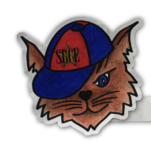
SBCE PTA Meeting
July 29th @ 7:00pm via Zoom
Meeting Minutes

Meeting began at 7:04pm

Attendees included: Daphne Honore, Tamara Liles, Michele Allison, Holly Smith, Heidi Mueller, Eva Kim, Isha Lee, Diedre Green-Richards, Carrie Finn, Kathleen Newquist, Erin Nichols, Tiffany Jansen, Elizabeth Cook, Lynda Nicolay and Emily Lovelace.

Welcome!

Thank you PTA Committee members for joining our Zoom call today to discuss what PTA will look like for the coming school year, go over the end of last years budget and review the communication that we will be sending out to parents regarding PTA.

Topics for discussion are:

- August Sneak Peek (what does that look like this year?) – with the school starting with virtual learning, Sneak Peek will also be virtual. Teachers will be recording a welcome message to share with their classroom and those parents. Mrs. Marques and Mrs. Kyle are going to attach the PTA power point presentation to these emails for parents to see. Click CTRL and Enter to view the PTA presentation. Thank you to Daphne for putting this together!

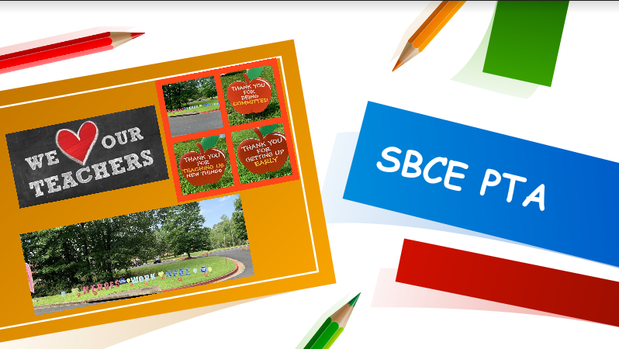

- The 2020-2021 proposed PTA membership levels and benefits, which will probably be revised as some benefits will not be relevant this year (e.g. reserved parking at all-school family events) – The 2020-2021 Membership levels were reviewed with the committee and approved. Jennifer Rombardo will begin promoting membership next week.

MEMBERSHIP LEVELS 2020-2021
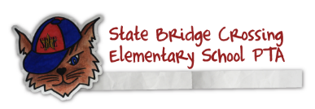
Welcome to State Bridge Crossing Elementary School! We are excited to have your family become a part of our community!

The PTA plays a significant role here at SBCE, be we cannot do it without our members. 100% of your donation goes directly to support SBCE programs. Please take this into consideration when deciding which level to choose when joining. SBCE PTA is a 501(c)(3) not-for-profit agency. Check with your employer to see if they offer company matching gifts. If you need assistance or have questions regarding company matching please contact us @ sbcepta@outlook.com

$500 Platinum Level
- Credit of $100 towards SBCE Spirit Wear Store
- Bookfair Credit of $25
- Family tickets (up to 4) to Family events this Spring (Spring Festival & Movie Night)
- Reserved Parking Spot at Family events
- Free SBCE Yearbook
- SBCE Platinum Member Yard Sign
- Access to the online school directory

(TAX DEDUCTIBLE AMOUNT $425 – EIN 58-2247123)

$250 Gold Level
- Credit of $50 towards SBCE Spirit Wear Store
- Bookfair Credit of $10
- 2 tickets to Family events this Spring (Spring Festival & Movie Night)
- SBCE Gold Member Yard Sign
- Access to the online school directory

(TAX DEDUCTIBLE AMOUNT $208 – EIN 58-2247123)
$155 Silver Level
- Credit of $25 towards SBCE Spirit Wear Store
- Bookfair Credit of $5
- SBCE Silver Member Yard Sign
- Access to the online school directory

(TAX DEDUCTIBLE AMOUNT $137 – EIN 58-2247123)

$80 Base Level
- Credit of $10 towards SBCE Spirit Wear Store
- Access to the online school directory

(TAX DEDUCTIBLE AMOUNT $74 – EIN 58-2247123)

$30 Minimum Level
- Credit of $5 towards SBCE Spirit Wear Store
- Access to the online school directory

(TAX DEDUCTIBLE AMOUNT $27 – EIN 58-2247123)

- Spirit wear sales – Emily Lovelace worked this summer to create new Bobcat Spirit Wear and work with our vendor to build an online store. This online store offers parents the option to purchase spirit wear to pick up or to have it shipped to their home for a flat shipping rate of $8 if the order is under $50, free if it is over $50. The store will be open beginning next week and remain open until August 23rd.

- School Box Kits – Jill Francis was on our committee to oversee and work with the vendor of the school box kits. Jill did a great job over the summer to work with the teachers on the supply list and then with the vendor to get this up and running. Due to Covid19 and the county wide decision to do universal remote learning, our sales this year were down. We sold 57 school box kits. The vendor will continue to work with us in the event that we do return to face to face learning and parents will have the option to place orders at that time to be delivered to the school. We would like to thank Jill for all of her hard work and dedication to the school box kits. She is amazing and will be missed!

- Family Portraits – Aubry was not able to join our call this evening, but we are working on setting up dates and times for Family Portraits! Be on the look out for the sign up!

- Box Tops – Heidi put together a new poster for Box Tops App and spoke to us about the new scanning process that we will be promoting this year. Instead of cutting box tops and sending them in and the fact that it could be challenging to count those and send them in due to Covid 19, we will heavily promote scanning receipts.

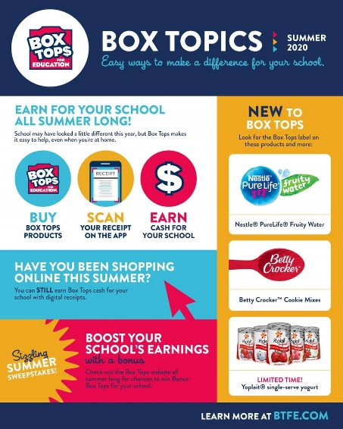 | 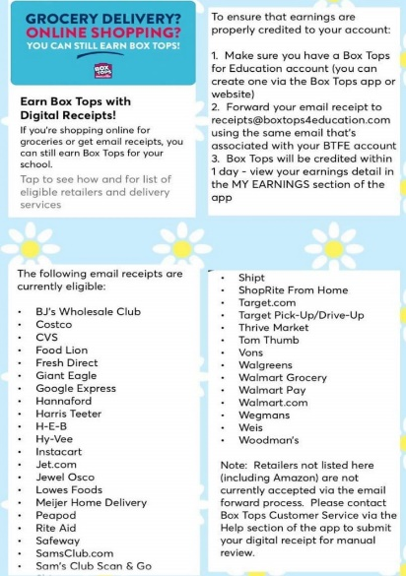

Dear SBCE Parents and Faculty,
Digital box tops are here. What does that mean for SBCE PTA? All boxtop credits will be received electronically either by scanning your receipt or emailing it to boxtops. What this means is you need to download the app onto your smart device (see links below) and scan your receipt with all participating box top items from any retailer (grocery store to gas station). See the instructions and participating stores for digital receipts that include participating items. A list of all participating brands is available on the app and website. You will now be able to watch how much you are contributing to the school through the app.
I have used the app and enjoyed the instant gratification of seeing my contribution via the app and email confirmation. Additionally, you can see how much you have contributed and the school has earned from July 1, 2020 – June 30, 2021. Throughout the year, there are bonus offers that double and triple what is contributed to the school. These offers from various retailers and participating items are updated on the app all the time. Currently bonus offers are available at Kroger, Walmart, Target, Costco and Sam’s.
One last important bit of information…Receipts must be scanned within 14 days of purchase for credit.
If you have any questions please contact me at Heidiag94@ymail.com.
Click here for the app on Apple Devices
Click here for the app on Android Devices
Good luck scanning and keep sending in the box tops to earn money for SBCE PTA!
Heidi Mueller
Box Top Coordinator

- A review of current officers and roles and any changes that may impact these roles – See the list below of the current PTA committee board members and any open positions below

Co-Presidents Update - Tamara Liles & Daphne Honore
Principal Update - Mrs. Marques
Teachers Update –
Treasurer Update – Open
School Governance –
Academics Updates :
Mini Grants – Michele Allison
Science Force – Daphne Honore
Reed to Succeed – Lindy Washer
Finance Updates :
Member Toolkit – Jennifer Rombardo
Social Media – Jennifer Rombardo
PTA Website – Tamara Liles
PTA Bookfair – Holly Smith
Family Portraits – Aubrey Canales
Box Tops – Heidi Mueller
Spirit Wear – Emily Lovelace
Yearbook – Eva Kim & Isha Lee
Community Support :
Room Rep Coordinator – Michele Allison
Gardening & Landscaping – Lynda Nicolay
Hearing & Vision –
Teacher Breakfast – Deji Ann Simms
Teacher Appreciation – Ashley Jarc
Newcomers Committee – SaraBeth Grow & Saiesha Sylvester
All Pro Dads – Pete Lovelace
Family Events :
Raffle Basket Coordinator –
Bingo – Diedre Green-Richards & Anna McIlroy
Fall Festival –
Walk to School Coordinator – Elizabeth Cook
Daddy Daughter Dance – Tiffany Jansen
Mother Son Event – Erin Nichols
Field Day – Carrie Finn & Kathleen Newquist
5th Grade Finale Coordinator – OPEN POSITION (Must be filled by a parent with a current 5th grade student)

- A review of the final 2019-2020 budget/financials and a preliminary discussion of the 2020-2021 budget planning process – a review of the current budget was gone over and we talked about what our budget will look like for the coming year. It is noted that the budget is being planned on our students coming back to face to face school by spring and that the budget is subject to change for this school year due to Covid19. Please see the budget for the end of last school year with actuals as of July 1st, 2020 that was reviewed located on the SBCE PTA website. Daphne and I will be working on the purposed budget for this school year and have that ready for PTA members to approve at curriculum night in September.

Discussion – Daphne and I have met with Mrs. Marques and Mrs. Kyle about how the PTA can support SBCE this year. Some of the things that were discussed were:
Teacher/school needs - iPad covers, iPad charging carts, hand sanitizer, paper towels, bottled water, recycle bins for the plastic bottles, lanyards, face shields and clear tri-folds, yard signs to welcome teachers back.
Teacher back to school breakfast and lunch – these will need to be individually wrapped and boxed items for teachers to grab and go. They will not be able to congregate as they typically do in the past.
Room Parent needed? – YES! We still want to have a room parent to assist with teacher holiday and end of year gifts. And if we do come back to school we will still have some sort of classroom party. It will look different, but we want to celebrate!
Bookfair – working with Mrs. Justice to understand what that will look like this year with Scholastic. Holly Smith is our committee chair person and she is on top of this for our PTA spring bookfair as well.
Science Force – not able to have science force at this time but PTA offered to assist Mrs. Huber with any needs she may have.
Hearing & Vision – we will need to get an update from the school nurse if the children return as to whether or not we can do it this year and how it will be done.
Fall Festival – if the kids go back face to face we might be able to do a Spring Festival
Movie Night – this is another outside family event that we may be able to do in the spring
PTA meetings – these will continue to be via Zoom until things reside back to normal.

