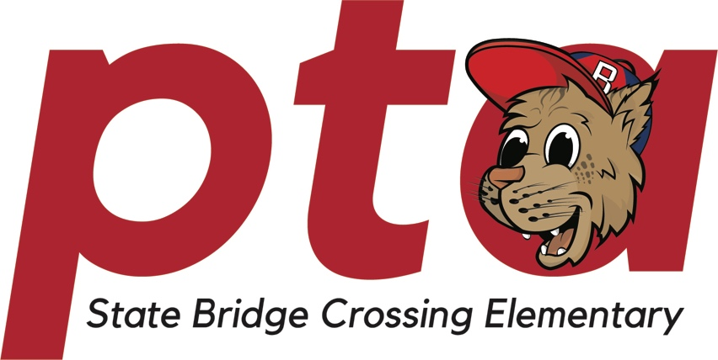

Welcome to State Bridge Crossing Elementary School’s Parent-Teacher Association (PTA)! Our mission is to create a vibrant and inclusive community where parents, teachers, students, and staff collaborate to nurture a positive learning environment that fosters growth, compassion, and success.

Our Core Values:

1. Collaboration: We believe that when parents and teachers work together, incredible things happen. By joining forces, we can create enriching experiences and effective support systems that help every child reach their full potential.

2. Student-Centered Focus: Our primary goal is the well-being and development of our students. We strive to provide opportunities that enhance their academic, social, and emotional growth, ensuring they become confident, well-rounded individuals.
3. Inclusivity: Diversity is our strength. We embrace the uniqueness of each family and create an environment where everyone feels valued and respected. By celebrating our differences, we enrich our perspectives and foster a sense of belonging.

4. Continuous Improvement: We are committed to seeking innovative ways to enhance the learning experience. Through open dialogue and active participation, we aim to continually improve our school's facilities, curriculum, and resources.

5. Community Engagement: Our PTA extends its reach beyond the school walls. By partnering with the broader community, we create connections that enrich the lives of our students and families, promoting a sense of responsibility and global citizenship.

Our PTA's Initiatives:
1. Enriching Education: We strive to complement classroom learning by supporting engaging programs like Science Force, Read to Succeed, and direct to classroom support through teacher stipends and classroom mini grants.
2. Supportive Environment: We work to create a safe, supportive, and nurturing atmosphere where students can thrive. By addressing both academic and socio-emotional needs, we help students develop the skills and confidence to succeed.
3. Teacher Appreciation: Our teachers are the heart of our school. We honor their dedication and hard work by providing resources, recognition, and a platform for collaboration. PTA hosts teacher appreciation breakfasts and lunches throughout the year, as well as, organizing Teacher Appreciation Week.
4. Community Building: Through engaging events, social activities, and volunteering opportunities, we strengthen the bonds between families, teachers, and students. These connections build a sense of community that extends beyond the classroom. We hope you’ll join us for one of our Family Events this year – Fall Festival, Bingo, Daughter’s Choice Dance, and the Son Plus One Event.
5. Advocacy: We advocate for policies and resources that support our school's mission. By raising our collective voice, we work to ensure that every child has access to a high-quality education and a nurturing environment.
Join Us in Making a Difference:
We invite every parent, teacher, and community member to be a part of our PTA. By contributing your ideas, time, and energy, you play a crucial role in shaping the educational journey of our students. Together, we empower each other and our children, fostering a culture of learning, growth, and positivity.

